LAB-1.
Draw the graph of f (x) =2x³+5x² and g (x) =-3x³+7x² in single plot in Mathematica.
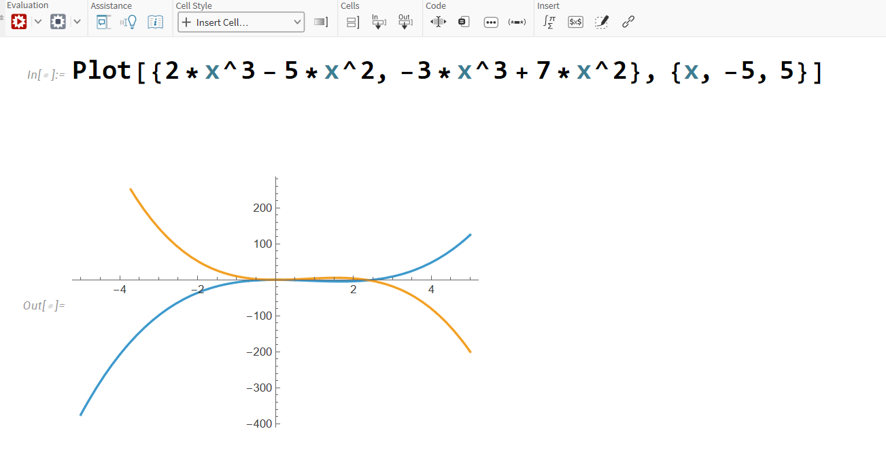
LAB-2.
Compare the nature of the graph of f (x) =5^{x},f (x)=2^{x} ,f(x) =e^{x} in Mathematica.
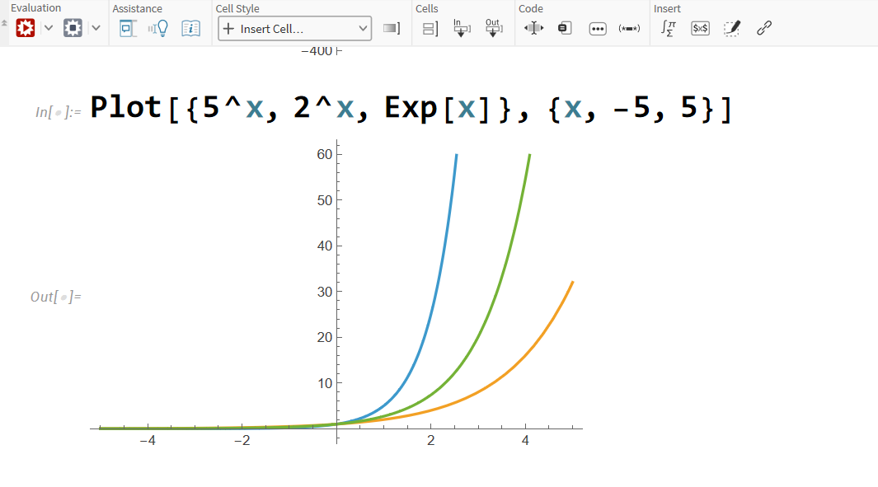
LAB-3.
Find the value of f (x) =x²-5x+6 at x=2 using Mathematica.

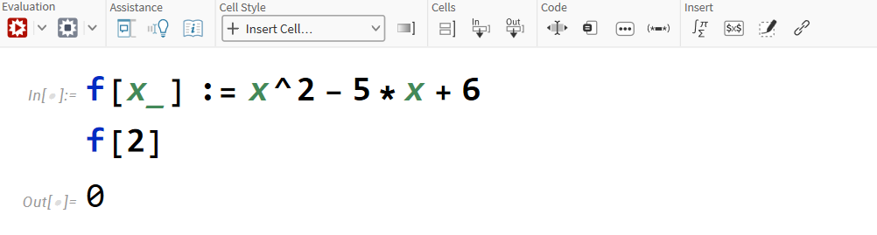
LAB-4.
Draw the graph of function f (x) =ln(1+x) for x$∈$[-6,6] in Mathematica.

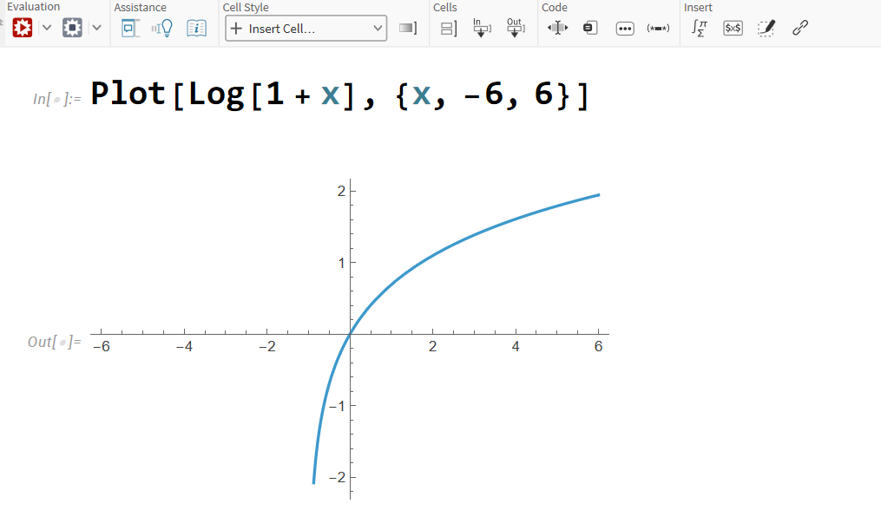
LAB-5.
Let f: R R define by f (x)=x²+5x+7 and g: R R define by g (x)= 5x-2, find fog (2) and gof (3) in Mathematica.

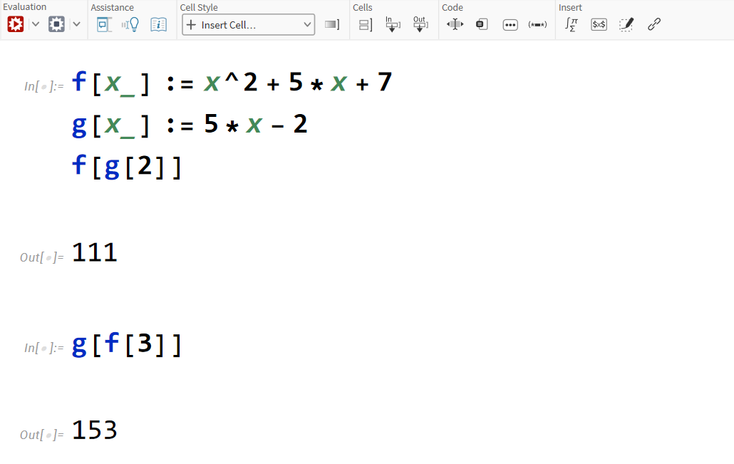
LAB-6.
Draw the graph of f (x) =e^{2x} in Mathematica for x$∈$[-4,4].

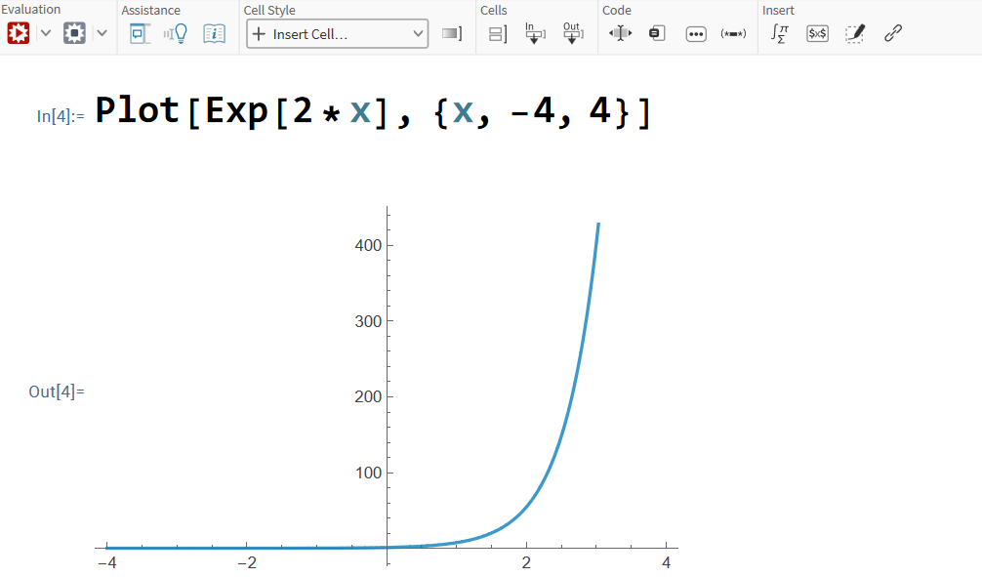
LAB-7.
Write the following Piecewise functions f(x)= {x^2+1 for x<=1 and 2x+3 for x>=1} then draw the graph for x$∈$[-5,5] and find f (0), f (-5), f (3), f (10) in Mathematica.

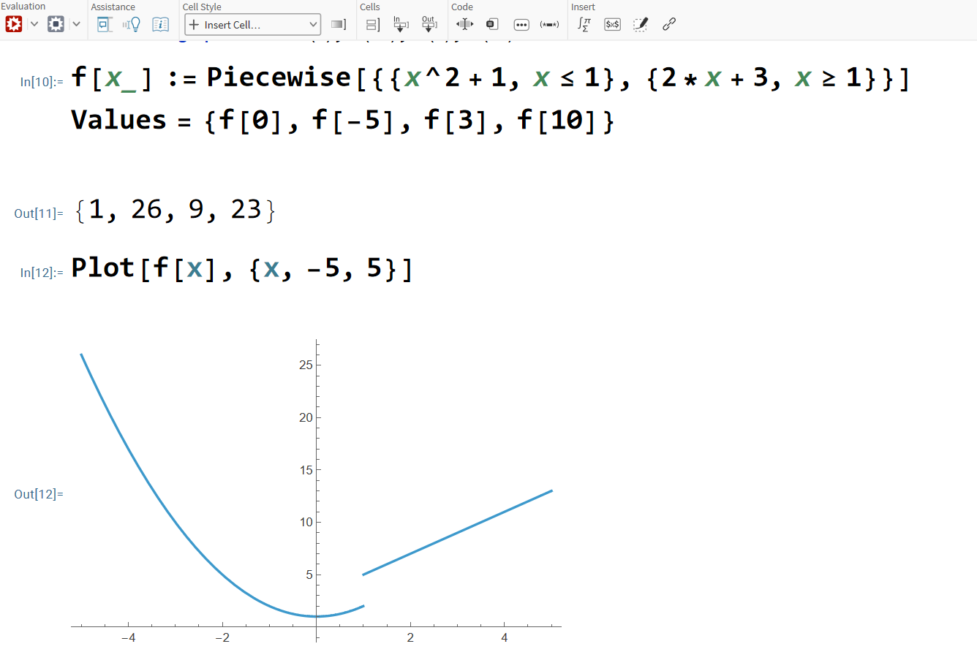

LAB-8.
Plot a circle with center(-2,-3) and having radius 3 in Mathematica.

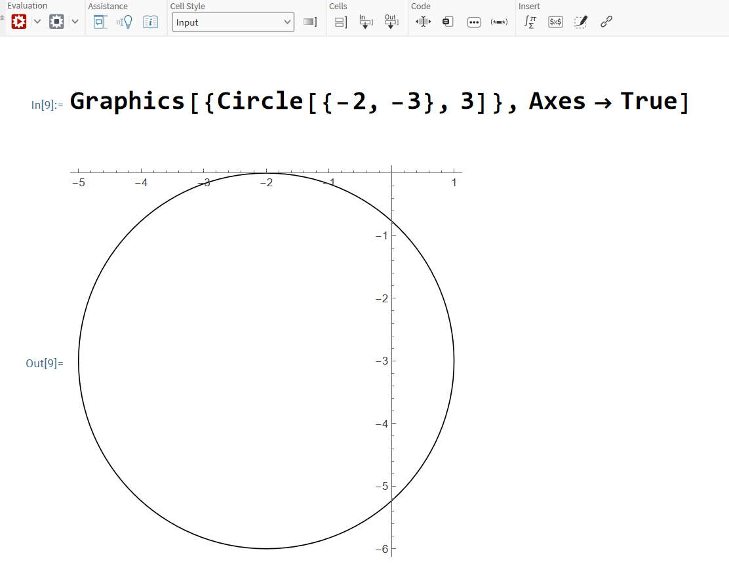

LAB-9.
Plot an ellipse $\frac{{\left(x-1\right)}^{2}}{64}+\frac{{\left(y-2\right)}^{2}}{16}=1$ in Mathematica.

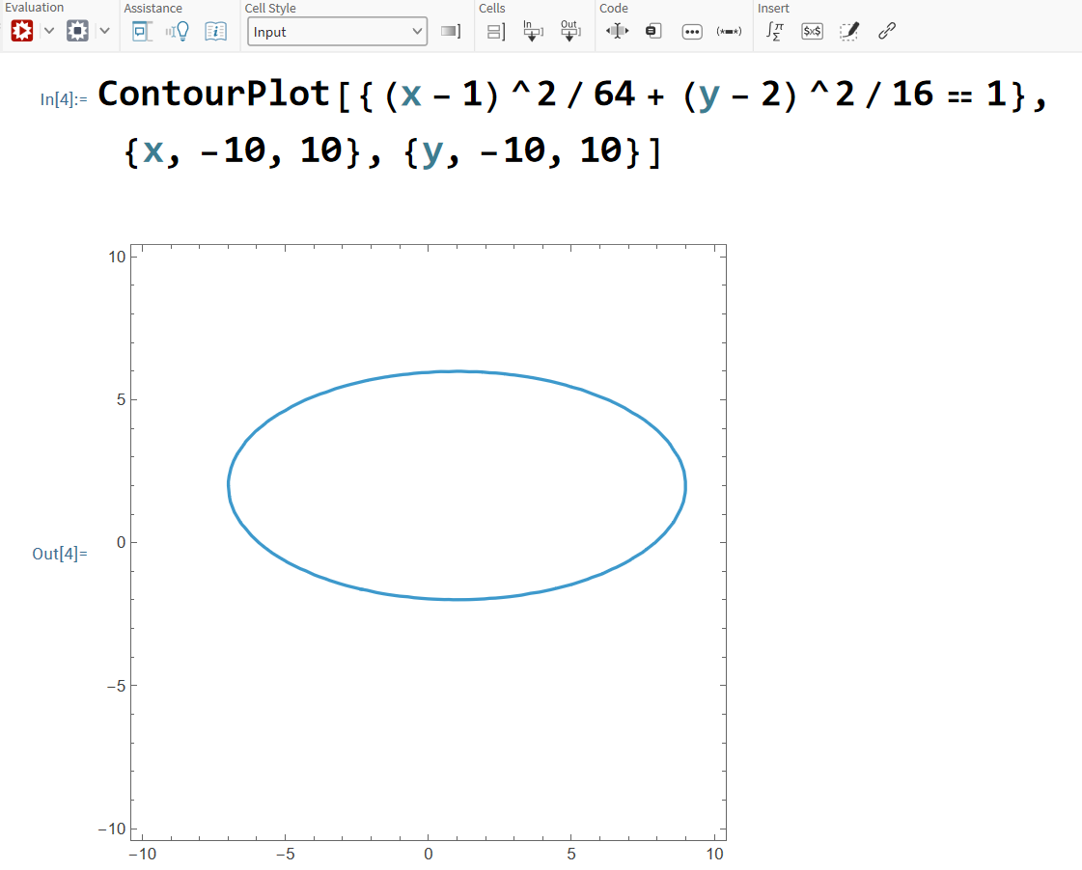

LAB-10.
Plot an ellipse $\frac{{\left(x-1\right)}^{2}}{25}-\frac{{\left(y-2\right)}^{2}}{16}=1$ in Mathematica.

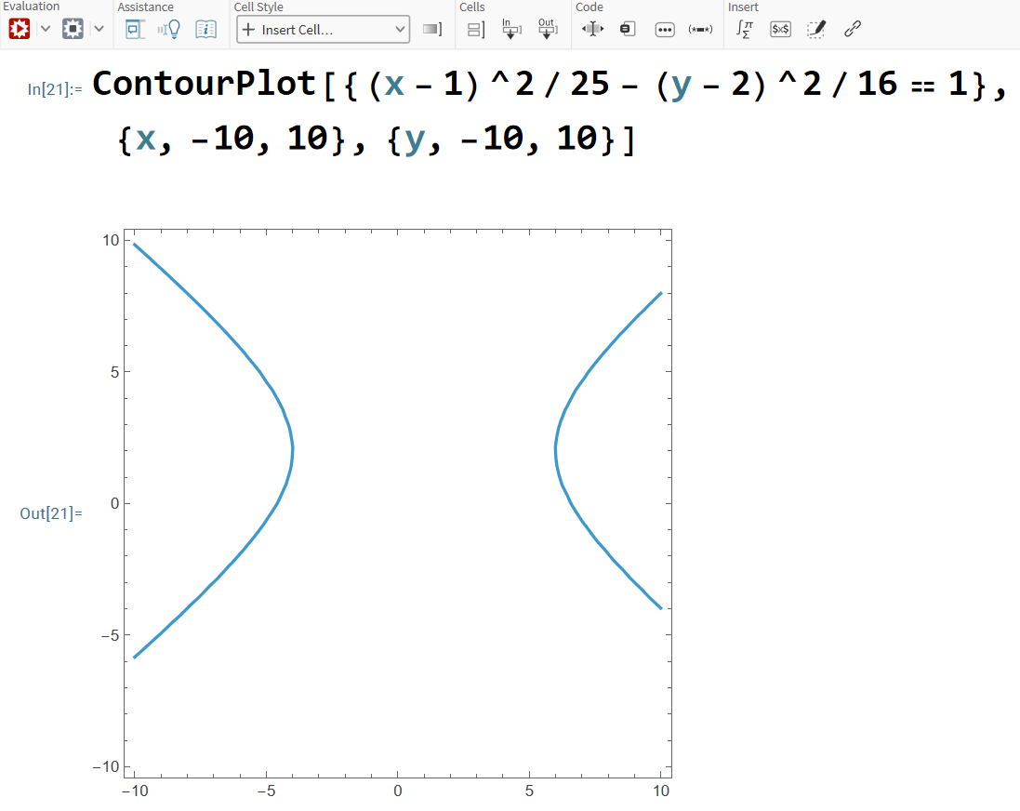

LAB-11.
Plot a parabola of equation (y+3)² =4(x+5)² in Mathematica.

